Shopify Sales Data Analysis

1.Project Overview

This project analyses sales of Shopify from 60K orders across various product categories. The main goal is to analyse profit and revenue performance mainly done by the major product categories in the data.

2.Dataset Summary

  - Columns- 17
  - Rows- 60000
  - Data consist of orders of products from the year 2023 to 2025 with price of products, revenue, profit, discount ect...

3.Data Analysis using Python

Data preparation and cleaning was performed by using python.

  - Data loading: Imported dataset using pandas.

  - Data exploration: Used df.describe() for summary statistics and df.info() for data structure.

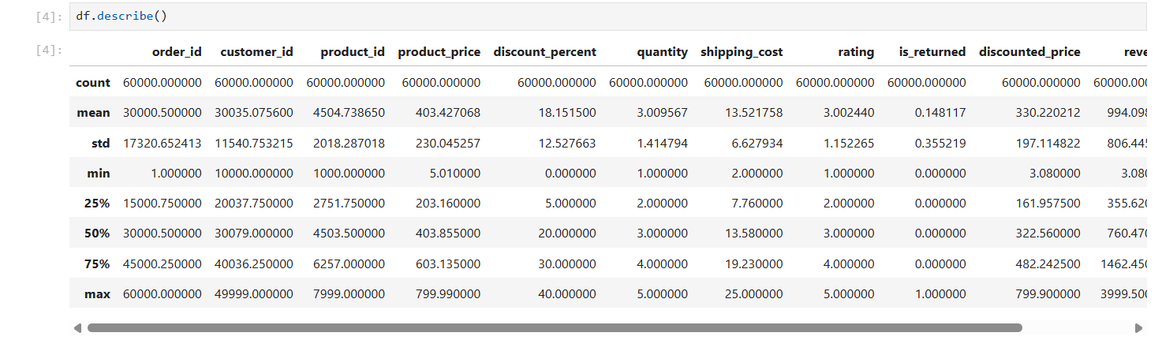

  - Data cleaning and processing: Changed few Data types and checked for any missing values.

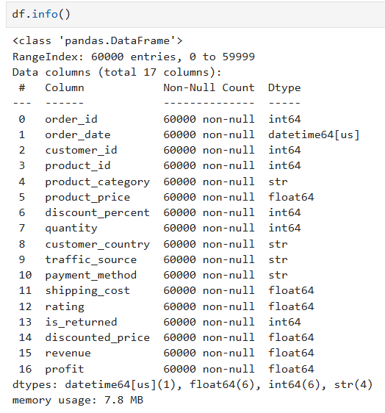

  - Database integration: Connected python script to MS SQL and loaded cleaned dataset into the database for SQL analysis.

4.Data Analysis using SQL

Structured analysis in MS SQL was used to answer business questions:

  - Revenue by category: Calculated revenue created by each category and found which ones created high revenue.

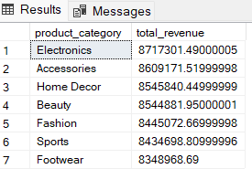

2. Profit by traffic sources: Found which traffic sources contributed most profit.
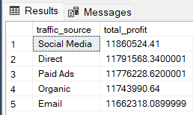

3. Sales by Country: Found which country has highest sales.

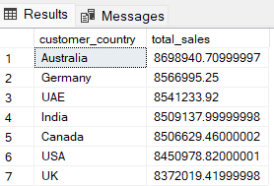

4. Return by category: Found which category has high return of products after receiving the product.
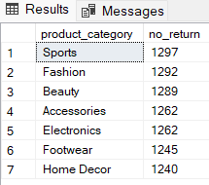

5. Profit by product: Calculated which products give high profit to the business.
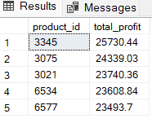

6. Monthly revenue: Found total revenue for each month.

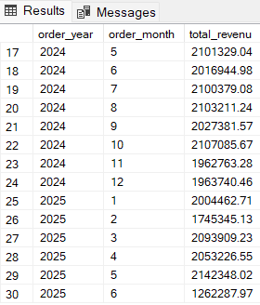

7. Payment method: Found the top payment methods used by the customers to pay for the items purchased.
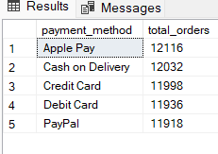

5.Dashboard in Power BI

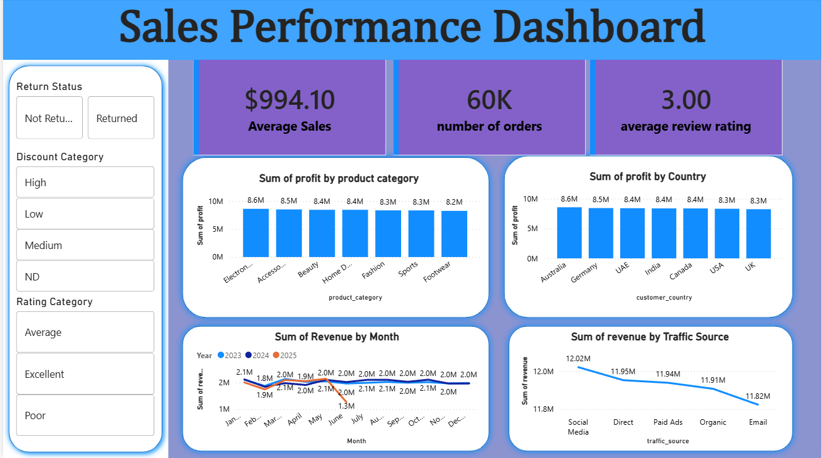

6.Business Recommendation

1.Invest more on high profit product categories electronics and accessories, but also do not exclude low profit product since the profit between the products does not have much difference.

2.Give focus on low performing countries. Provide local promotion for the business. It may result in better international revenue distribution.

3.Strengthen traffic channels. According to analysis social media gives more revenue than email but do not loose focus on email because is doesn’t have much difference in revenue.

4.Reduce product returns to protect profit. Identify products with high return and improve product description and images.

5.Payment method usage is almost perfectly even so there is no single channel to prioritise or worry about loosing.

